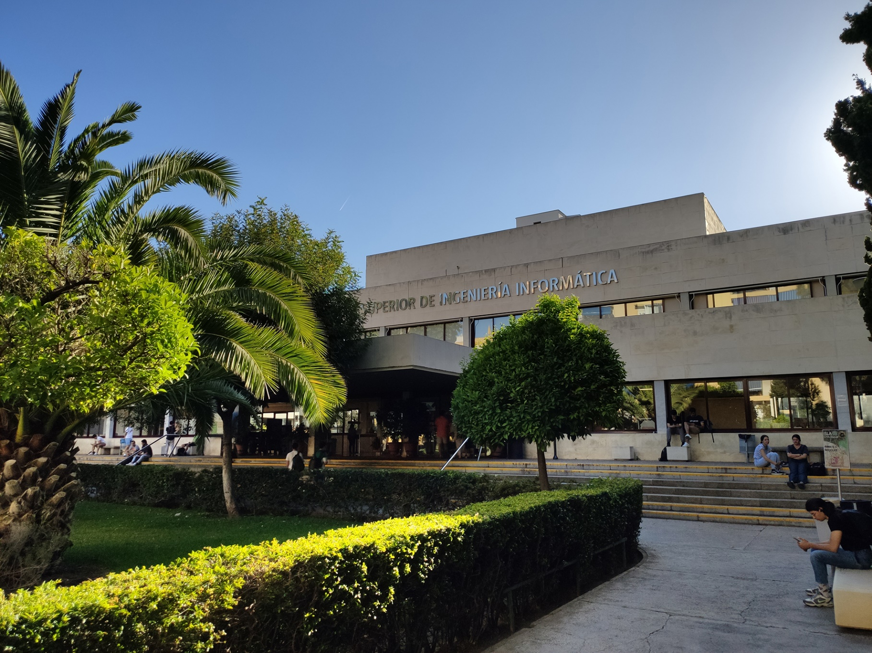

|  |
| --- |
| Planning Report |
| Members:   1. Jesús Cárdenas Conejo   (jescarcon@alum.us.es)   1. Antonio José López Cubiles   (antlopcub@alum.us.es)   1. Pedro Jesús Ruiz Aguilar   (pedruiagu1@alum.us.es)   1. Ismael Ruiz Jurado   (ismruijur@alum.us.es)   1. ✍️(◔◡◔) |
| 17-02-2023  Group: C1.02.10  Repository: https://github.com/jescarcon/Acme-L3-D01-23.1 |



Table of Contents

Executive Summary 3

Version History 4

Introduction 5

Contents 6

Conclusions 7

Bibliography 8

# Executive Summary

In this document you will find relative information about how is the proyect split in tasks, we decide to write it in a table where you can find for every task : His Title, Succinct Description, Assignee/s and Role/s , Planned Time and Actual Time then we calculate the price of the work done

# Version History

|  |  |  |
| --- | --- | --- |
| Version | Date | Description of changes |
| 1.0 | 17/02/2023 | Creation of the document |

# Introduction

1. In this document i will introduce a table for the individual tasks of the project. Every new row includes the title of the task, a succinct description of the task , the role, the planned time for doing the task and the final time for that task. At the final column cost of the task is calculated.

The cost stablished for the task is 30 €/h for the manager and analyst role tasks and 20 € for the developer ones.

# Contents

|  |  |  |  |  |  |
| --- | --- | --- | --- | --- | --- |
| Title | Succinct Description | Assignee/s and Role/s | Planned Time | Actual Time | Cost |
| Functional requirements | Modify the anonymous menu so that it shows an option that takes the browser to the home page of your favourite web site. The title must read as follows: “〈id-number〉: 〈surname〉, 〈name〉”, where “〈id-number〉” denotes your DNI, NIE, or passport number, “〈surname〉” denotes your surname/s, and “〈name〉” denotes your name/s. | Developer | ~25’-30’ | 27’ | 9€ |
| Analysis Report | Create Analysis Report | Developer | ~20’-30’ | 22’ | 7,33€ |
| Planning Report | Create Planning Report | Developer | ~20’-30’ | 23’ | 7,67€ |

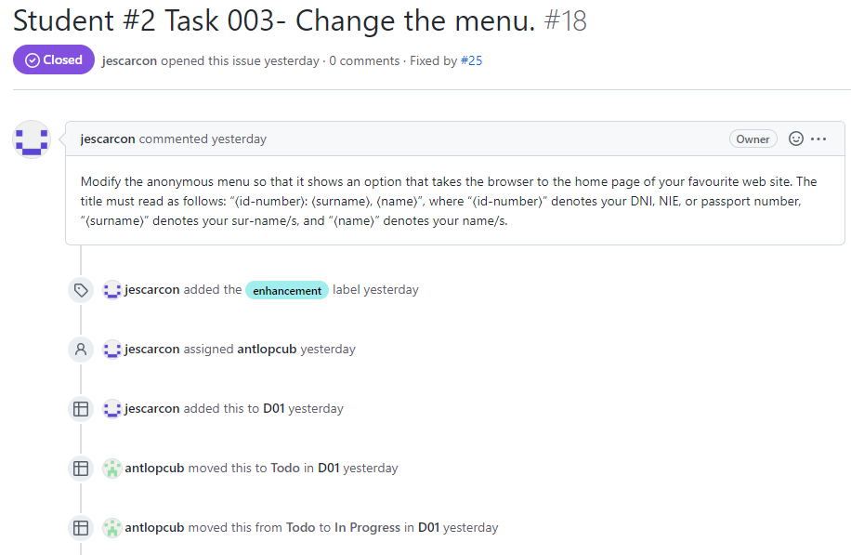 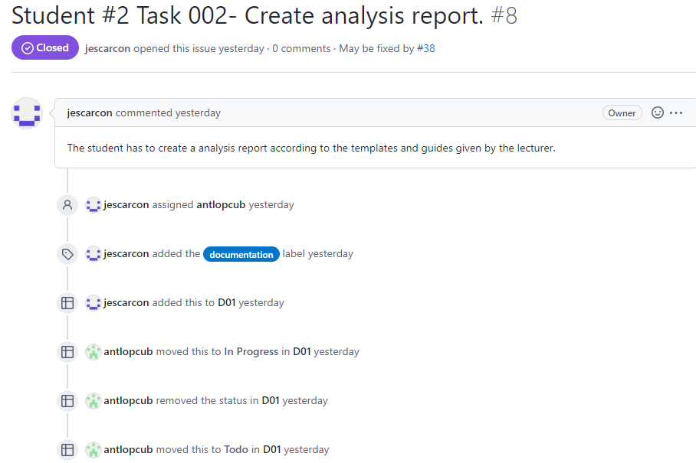

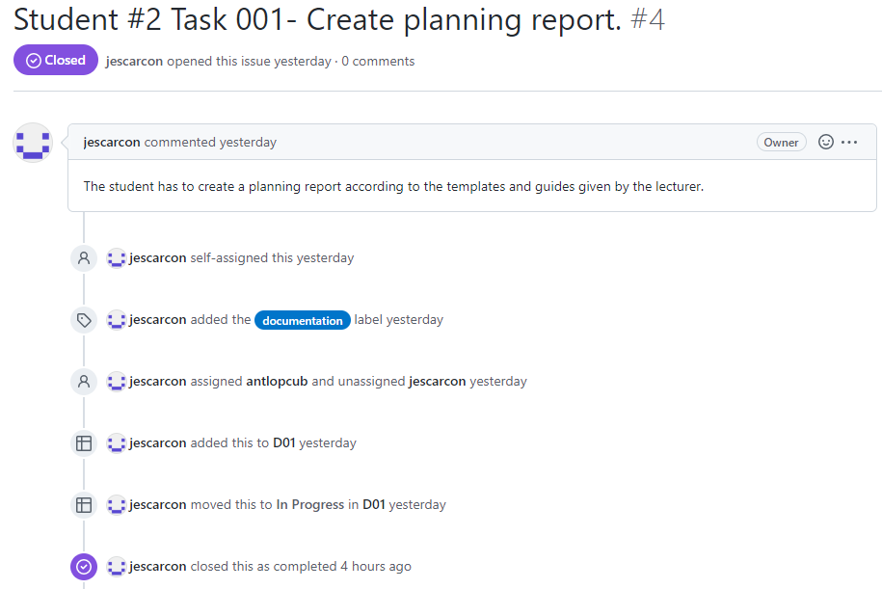

# Conclusions

This first requirements are simple as I’m starting the project. The knowledge acquired will help in the future requirement develop. The time estimations were more or less accurate.

# Bibliography

Intentionally blank.